**2008 BMW M1 Homage**

[**Home**](http://www.supercars.net/index.html) **→** [**BMW**](http://www.supercars.net/Search2?INPUT=BMW) **→ M1 Homage**

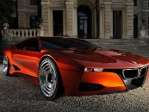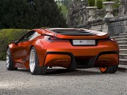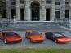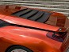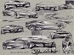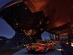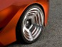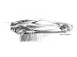

Above Images ©Matteo TT Stucchi @ 2008 Villa D'Este Concours

**Gallery Images**

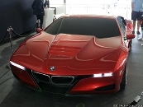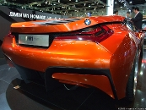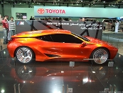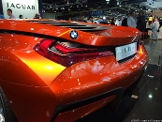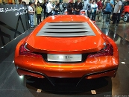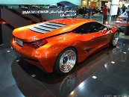

[**more gallery images**](http://www.supercars.net/Gallery?cmd=viewCarGallery&carID=4134&pgID=1)

At the Villa d'™Este Concours, BMW ignited passion for its heritage by reincarnating the seminal M1. The new design was shown at a private party over the weekend to generate interest in the program. It was placed alongside an original M1 as well as the 1972 Turbo Concept.

Thirty years ago BMW boldly entered the supercar market with the M1. Being a production racing car, it was a huge leap forward in both engineering and style. Thus, the M1 became an icon of BMW performance in the seventies. But it also became a singularity, since the cars relatively poor performance in motor sport hindered the prospects for a successor.

Reviving names of past models and modernizing them for the current market is a delicate balance. Considerations have to be made for safety, increased performance and retro styling as well as keeping the dedicated enthusiasts onboard. BMW are no strangers to retro design, their revival of the Mini has been a large success. This is contrasted by the new one-series and their romantic comparison to the 2002. The latest name that faces BMW designers is the M1.

The scope of the new M1 project is uncertain, but BMW are dedicated enough to champion the new visual design. At the Villa d’Este Concours they showed a non-functional styling buck, with no engine and interior, but with working lights and steering.

Like the original, the new M1 project is sleek, wide and ahead of its time. The car is painted a brilliant hue of metallic bronze, just like the first M1 prototype of 1972.

The 2008 M1’s styling is a new direction for BMW and a departure from Chris Bangle’s flame surfacing that changed the entire BMW line. Now we have more purposeful lines, a void of extraneous curves and a more purposeful stance. BMW said this was a new direction that would trickle down to all BMW models.

When revealed to our photographer, Matteo TT Schucchi, his first impression was that “pictures can't really show the real presence, but it really is amazing, with some incredible lines, and definitely a great modern interpretation of the M1.”

Next week the car will be officially unveiled by Auto Bild and BMW themselves.

Read more at <http://www.supercars.net/cars/4134.html#hXidQtTSxHT0BwYZ.99>